***My family***

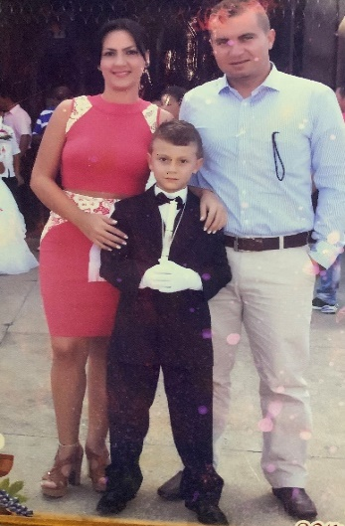My family is very important to me. My mom, Sandra, is a lawyer and specializes in labor law. She's been incredibly successful in her career, and I admire her hard work and dedication. She's turning 38 on August 3rd, and I'm excited to celebrate her birthday with her.

My dad, Jaime, is turning 40 on March 21st. He's a business administrator and lawyer, and he moved to the United States four years ago. It was difficult for me when he first moved away, but I'm glad that I'm able to visit him every six months. We always have a great time together, and I treasure those visits.

My little sister, Emma, is turning 6 on July 29th. She's currently in school in transition and is very intelligent. It's amazing to watch her grow and develop her skills, and I'm so proud of her.

As for myself, I'm currently studying software engineering, which is a field I'm really passionate about. I'm excited to see where this career path takes me, and I'm grateful for the support and encouragement of my family along the way.

Overall, my family is the most important thing in my life. I feel incredibly lucky to have such wonderful people in my life, and I know that I can always count on them for love and support.